**Monitoring Kubernetes Cluster with Dynatrace**

**Dynatrace:**

Dynatrace seamlessly brings infrastructure and cloud, application performance, and digital experience monitoring into an all-in-one, automated solution that is powered by artificial intelligence. Dynatrace assists in driving performance results by providing development, operations, and business teams with a shared platform, metrics. In this way, Dynatrace can serve as our organization's single "source of truth".

**How Does Dynatrace works:**

There are three concepts that are key to understanding how Dynatrace works:

* **OneAgent** – a single agent that automatically discovers instruments and collects high-fidelity monitoring data from everything in your IT environment.
* **Smartscape** – an interactive environment topology map that visualizes the dynamic relationships among all your application components across every tier.
* **Davis®** **AI engine** – analyzes everything (including all relationships and dependencies within complex IT environments) to provide answers, not just data. Davis® tells you when there is a problem, the business impact of the problem, and the root cause of the problem so that you can fix it quickly, including automated remediation through integration with your CI/CD tools.

1. Start the Minikube Cluster

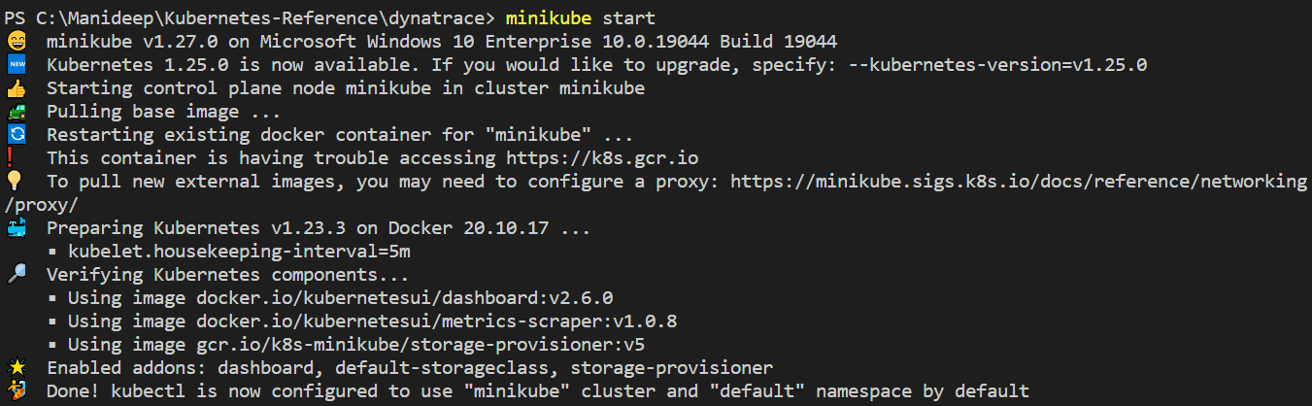

1. Login into Dynatrace
2. Install OneAgent for Kubernetes

1. Create the namespace with the name “Dynatrace’



1. Deploy the yaml files from the github

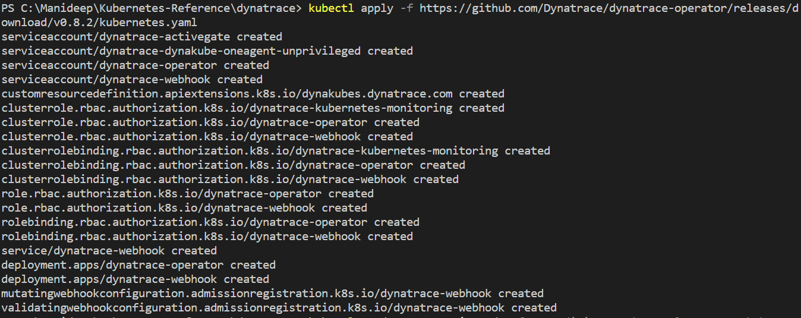



1. Download the yaml file from the Dynatrace website

1. Apply the yaml file.



1. Open the Cluster “minikube”

